HackathonSubmission (Level-1-Solution)

**Use Case Title : Weather Dashboard**

**Student Name: Srinithi S.S**

**Register Number: 20223131506222**

**Institution: Pioneer Kumaraswamy College, Nagercoil**

**Department: B.Sc. Computer Science**

**Date of Submission: 20/03/2025**

**1. Problem Statement**

Travelers often struggle with **planning trips** due to **uncertain weather conditions**. Existing weather apps are either too complex or lack a **lightweight, fast, and user-friendly** interface for quick weather updates.

This project aims to develop a **simple yet effective** weather dashboard that allows users to **check real-time weather conditions** for any city before making travel plans.

**2. Proposed Solution**

The **Weather Dashboard** is a **web-based** application that enables users to:  
✅**Search** for any city’s weather conditions.  
✅**View temperature (°C/°F), humidity, and a short weather description**.  
✅**See visual weather icons** based on conditions (e.g., ☀️ Sunny, ☁️ Cloudy).  
✅**Experience a responsive and lightweight UI** for easy access on any device.  
✅**Handle errors gracefully** when an invalid city name is entered.

The solution will ensure **fast loading times** and an **intuitive design**, making it **ideal for travelers**.

**3. Technologies & Tools Considered**

✅**Frontend:** HTML, CSS (Bootstrap), JavaScript (ES6)  
✅**Weather API:**OpenWeather API (for real-time data)  
✅**Deployment:**Netlify, Render, or Railway  
✅**Version Control:**GitHub (for open-source collaboration)

**4. Solution Architecture & Workflow**

**Architecture Overview**

1️. **User enters a city name** in the search bar.  
2️. The **OpenWeather API** fetches real-time weather data.  
3️. The **UI updates dynamically** to display:

* Temperature (°C/°F)
* Humidity (%)
* Weather description (e.g., "Cloudy")
* Weather icon (☀️/☁️/🌧️)

4️. If the city name is invalid, an **error message** is displayed.  
5️. Users can **toggle between Celsius and Fahrenheit** for temperature.

**Workflow Diagram:**

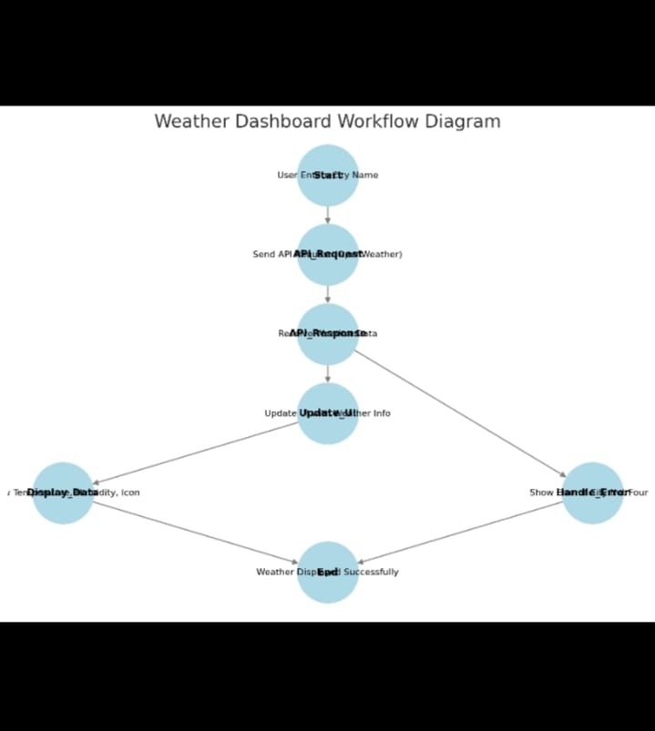

**5. Feasibility & Challenges**

**✅ Feasibility:**

* **Easy to implement** using HTML, CSS, and JavaScript.
* **OpenWeather API is free** (limited requests in the free tier).
* **Lightweight & fast** – can run on **any browser** without high resource usage.

**⚠️ Challenges & Solutions:**

1️. **API Rate Limits:** Free-tier OpenWeather API has limited requests per hour.  
🔹**Solution:** Cache results or use multiple API keys if needed.  
2️. **Network Dependency:** Users need an internet connection.  
🔹**Solution:** Implement offline fallback with last fetched data.  
3️. **UI Responsiveness:** Ensure smooth performance across devices.  
🔹**Solution:** Use **Bootstrap & CSS media queries** for a mobile-friendly design.

**6. Expected Outcome & Impact**

✔️**Real-time weather updates** for travelers before planning trips.  
✔️**Enhanced user experience** with a clean, simple, and responsive UI.  
✔️**Reduces last-minute disruptions** caused by unexpected weather.  
✔️**Easy access from any device** (mobile, tablet, or desktop).  
✔️**Open-source & community-driven**, allowing further improvements.

**7. Future Enhancements**

🔹**5-day weather forecast** feature for better travel planning.  
🔹**Dark mode toggle** for better visibility in low-light conditions.  
🔹**Geolocation-based weather updates** (auto-detect user’s location).  
🔹**Weather alerts** for extreme conditions like storms or heavy rainfall.  
🔹**Multi-language support** for global travelers.

Githublink :<https://github.com/praveenr1408/Weather-App>